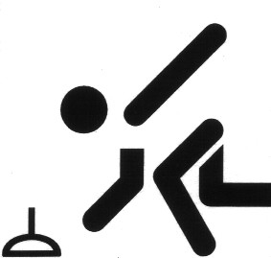

Elisabethsee
T r e f f p u n k t
1 7 : 0 0 U h r
S t o c k b a h n
W e n n ´ s h e i ß i s t
U m 1 8 : 0 0 U h r

